# Functions and Statements - Lab

Problems with exercise and homework for the ["JS Front-End" Course @ SoftUni.](https://softuni.bg/trainings/4240/js-front-end-october-2023)

## Format Grade

Write a function that **receives a grade** between **2.00** and **6.00** and **prints** a formatted line with **grade and description.**

* < 3.00 - "**Fail**"
* >= 3.00 and < 3.50 - "**Poor**"
* >= 3.50 and < 4.50 - "**Good**"
* >= 4.50 and < 5.50 - "**Very** **good**"
* >= 5.50 - "**Excellent**"

### Examples

|  |  |
| --- | --- |
| **Input** | **Output** |
| 3.33 | Poor (3.33) |
| 4.50 | Very good (4.50) |
| 2.99 | Fail (2) |

### Hints

* Use a series of if statements checking the threshold between grade brackets

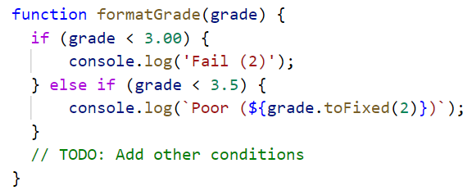

## Math Power

Write a function that **calculates** and **print** the value of a number **raised** to a **given power**:

### Examples

|  |  |
| --- | --- |
| **Input** | **Output** |
| 2,8 | 256 |
| 3,4 | 81 |

### Hints

* Create a function that will have **two parameters** - the **number** and the **power**.
* **Print** the result to the console.

## Repeat String

Write a function that receives a **string** and a **repeat** **count** n. The function should **return** a new string (the old one repeated **n** times).

### Examples

|  |  |
| --- | --- |
| **Input** | **Output** |
| "abc", 3 | abcabcabc |
| "String", 2 | StringString |

### Hints

1. Use a loop or another method to repeat the input string.
2. Use the return operator to produce the result.

## Orders

Write a function that calculates the **total** **price** of an order and prints it on the console. The function should receive one of the following products: **coffee, coke, water, snacks**; and a **quantity** of the product. The **prices** for a single piece of each product are:

* coffee - 1.50
* water - 1.00
* coke - 1.40
* snacks - 2.00

Print the result **formatted** to the **second** **decimal** **place**.

### Example

|  |  |
| --- | --- |
| **Input** | **Output** |
| "water", 5 | 5.00 |
| "coffee", 2 | 3.00 |

### Hints

* Create a function and pass the two variables in.
* Print the result in the function.

## **Simple** **Calculator**

Write a function that receives **three parameters** – two numbers and an operator (string) –and calculates the result depending on the operator. Operator can be **'multiply'**, **'divide'**, **'add'** or **'subtract'**. Try to solve this task using **arrow functions**.

### Bonus

Solve this task **without** using any conditional statements (no if or switch statements or ternary operators).

### Input

The input comes as parameters named **numOne,** **numTwo,** **operator**.

### Examples

|  |  |
| --- | --- |
| **Input** | **Output** |
| 5,  5,  'multiply' | 25 |
| 40,  8,  'divide' | 5 |
| 12,  19,  'add' | 31 |
| 50,  13,  'subtract' | 37 |

### Hints

* Use a switch statement for the different operators.

## Sign Check

Write a function, that checks whether the result of the multiplication **numOne * numTwo * numThree** is positive or negative. Try to do this **WITHOUT** multiplying the 3 numbers.

### Input

The input comes as parameters named **numOne,** **numTwo,** **numThree**.

### Output

* If the **result** is **positive**, print on the console -> **"Positive"**
* Otherwise, print -> **"Negative"**

### Example

|  |  |
| --- | --- |
| **Input** | **Output** |
| 5,  12,  -15 | Negative |
| -6,  -12,  14 | Positive |
| -1,  -2,  -3 | Negative |
| -5,  1,  1 | Negative |

### Hints

* Consider how the sign of each of the three input parameters will affect their product.
* Check all the different combinations for the three numbers.